GIT-HUB TASK 01

To SetUp MFA (Multi-Factor Authentication) for GitHub Using a Mobile App
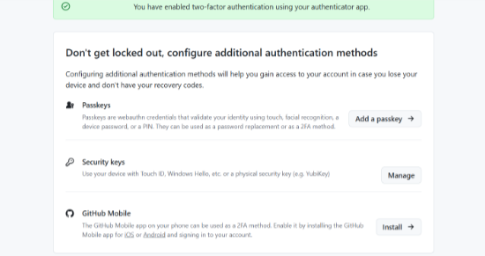
Enable two-factor authentication
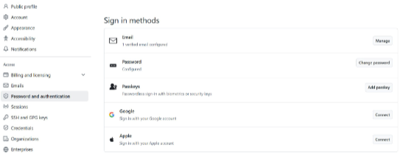
Initialising the git Using git init


$git status :

$git config –list
$git add

$git commit -m

$git log
$git remote -v

$ git push -u origin master

$ ssh-keygen
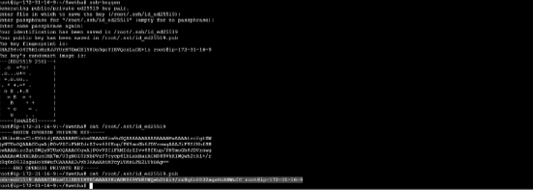
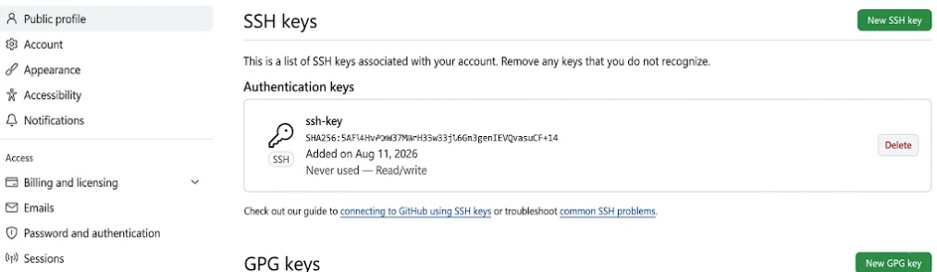
$rm filename


$git pull

$git clone


